**Maternal Health Services Database**

**GROUP 9**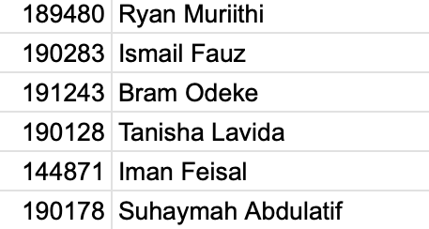

**Project idea definition**

Maternal mortality remains a significant challenge in Kenya, despite notable progress in recent years. Factors such as inadequate access to quality healthcare, limited prenatal care, and complications during childbirth contribute to this issue. The lack of a comprehensive and efficient system to track maternal health records hampers effective monitoring and intervention.

This project directly aligns with SDG 3 by aiming to improve maternal health outcomes. By developing a robust database system, we can:

* **Enhance data collection and analysis:** Accurate and timely data on maternal health indicators will enable policymakers and healthcare providers to identify trends, prioritize interventions, and allocate resources effectively.
* **Improve access to quality healthcare:** The system can facilitate the tracking of maternal health services, ensuring that women receive timely and appropriate care.
* **Strengthen healthcare delivery:** The database can support the development of evidence-based policies and programs to address specific maternal health challenges in Kenya.

Kenya has made significant strides in improving maternal health, but challenges persist, particularly in rural areas. A well-designed database system can help overcome these challenges by:

* **Reducing maternal mortality:** By providing real-time data on maternal health indicators, the system can help identify high-risk pregnancies and facilitate timely interventions.
* **Improving maternal and child health:** The system can support the integration of maternal and child health services, ensuring that women receive comprehensive care.
* **Empowering women:** By providing access to information and services, the database can empower women to make informed decisions about their reproductive health.

**Scope and objectives**

**Scope**

The database will cover the tracking of maternal health services for patients across various stages of maternity care including parental visits, delivery information and postnatal checkups. The system will also include the details of health practitioners involved and manage information on clinic locations and resources available.

**Objectives**

1. track patient information and medical history relevant to maternal health.

2. Record details of each prenatal visit including tests and results

3. Log delivery details such as type of delivery, health personnel involved and birth outcomes.

4. Documents post Natal follow-up visits including health assessments and care provided.

5. Ensure data integrity and enabled easy retrieval of patient information for ongoing care.

**Stakeholders**

1.**Patients** - beneficiaries of the system who will receive improved maternal care

2.**Health practitioners** - doctors nurses and midwives who use system to track patients progress and access medical histories

3**.Clinic administrators** - manage clinic resources and staff using the system for reporting and planning

4.**Health ministry officials** - uses data insights from the system to monitor maternal health metrics and guide policy decisions

**Relationships**

1. patient to clinic - a patient can visit multiple clinics and each clinic can serve multiple patients (many to many)

2. patient to doctor- a patient can see multiple doctors throughout their care and each doctor can treat multiple patients (many to many)

3. clinic to doctor- a clinic can have multiple doctors and each doctorr may work in multiple clinics (many to many)

4. patient to prenatal visit - a patient can have multiple prenatal visits recorded (one to many)

5. patient to deliver - a patient can have only one delivery recorded per pregnancy (one to one)

6. patient to post Natal visit - a patient can have multiple post Natal visits (one to many)